

[www.literacyindia.org](http://www.literacyindia.org)

session starts from

January 2024

Contact no. 8588853380

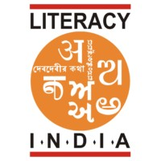

LITERACY INDIA

I.N.D.I.A

Programs Offered

* Robotics/tinkering
* Computer hardware
* Mobile repairing
* Cooking / Hospitality
* Beauty & wellness
* Stitching & cutting
* Electrical troubleshooting
* Two – wheeler repairing
* Mobile journalism
* Computer science
* Call centre / BPO
* Logisties
* Data digitization
* Natural farming market connect
* Banking



Literacy India community college(LICC)



Limited seats

Register now